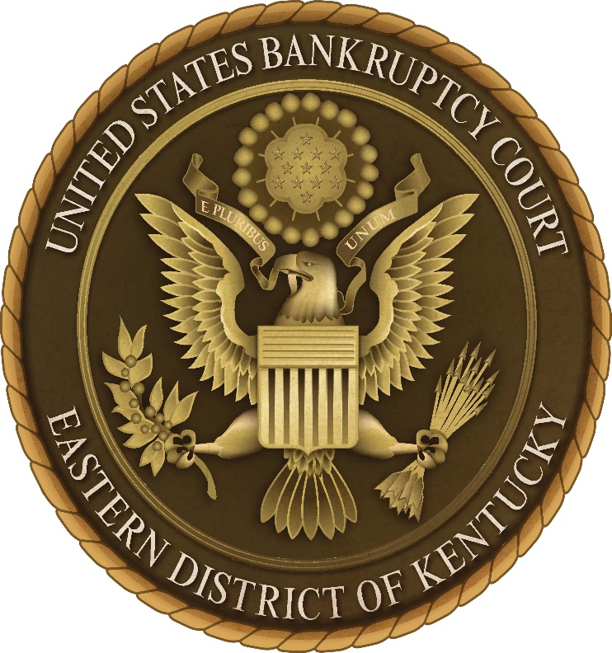

Employment Dispute Resolution Plan
Acknowledgment Form

I have received a copy of the Employment Dispute Resolution Plan (EDR Plan) for the United States Bankruptcy Court for the Eastern District of Kentucky. I understand that it is my responsibility to read and familiarize myself with the content of the EDR Plan. I further understand that if I have any questions regarding the EDR Plan or process, I can consult with Human Resources, the Court’s EDR Coordinator, the Circuit Director of Workplace Relations, or the national Office of Judicial Integrity.

I understand that the EDR Plan may be revised or amended from time to time and that a copy of any future revised EDR Plan will be available to me on the Court’s website. I can also request a copy at any time from Human Resources or the EDR Coordinator.

Employee Signature: _________________________________________________

Employee Printed Name: ______________________________________________

Date: _________________________

