ElderCare
LIFESTYLE SKILLS /
BUDGETING BASICS

LIFESTYLE SKILLS /
BUDGETING BASICS

KNOW YOUR MONEY, PROTECT YOURSELF

Budgeting. This is often seen as a scary word and a very complicated practice. Yet budgeting is a great tool for ensuring financial stability and protecting yourself from financial scams. The better you understand where your money goes and where it should be spent, the more you can protect yourself from financial predators.

What is a budget?
A budget helps you decide how much money to spend on one
item or another. A successful budget is realistic and customized
to your needs and wants.
43% of Americans say they spend more money than they earn.

What a budget is not.
A budget is not a financial straightjacket. It is not meant to keep
you from enjoying life. It can help you make better financial
decisions for the short term and long term.

Do I need a budget?
Ask yourself: Am I meeting all of my financial goals? If you have
at least one financial goal you aren’t meeting, then it may be time
for a budget.

What are financial goals?
Financial goals are different for everyone, but here are some
common ones:
- Being able to pay all your bills each month and having a little left over.
- Going on your dream vacation.
- Getting rid of credit card debt.
- Helping pay for your grandchildren’s college education.

MONTHLY INCOME & EXPENSES WORKSHEET

My Income |  | My Expenses
WAGES | $ | RENT/MORTGAGE | $
PUBLIC ASSISTANCE | $ | PROPERTY TAXES/INSURANCE | $
CHILD SUPPORT/ALLIMONY | $ | TRASH COLLECTION | $
INTEREST/DIVIDENDS | $ | CABLE | $
SOCIAL SECURITY | $ | CAR PAYMENT(S) | $
OTHER: | $ | CAR INSURANCE | $
 |  | OTHER LOAN PAYMENT(S) | $
 |  | HEALTH INSURANCE | $
 |  | SAVINGS | $
 |  | GAS/OIL | $
 |  | ELECTRICITY | $
 |  | WATER | $
 |  | TELEPHONE/MOBILE PHONE | $
 |  | FOOD-GROCERIES | $
 |  | FOOD-EATING OUT | $
 |  | TRANSPORTATION/GAS | $
 |  | CAR MAINTENANCE | $
 |  | CREDIT CARD | $
 |  | PERSONAL | $
 |  | OTHER: | $
TOTAL INCOME | $ | TOTAL EXPENSES | $

RECOMMENDED PERCENTAGES
Item | Actual | Recommended
CHARITABLE GIFTS | % | 10–15%
SAVING | % | 5–10%
HOUSING | % | 25–35%
UTILITIES | % | 5–10%
FOOD | % | 5–15%
TRANSPORTATION | % | 10–15%
CLOTHING | % | 2–7%
MEDICAL/HEALTH | % | 5–10%
PERSONAL | % | 5–10%
RECREATION | % | 5–10%
DEBTS | % | 5–10%

Compiled from several sources, this table shows guidelines for suggested spending percentages. However, these are only recommended percentages and can change dramatically based on your actual income. The lower the income, the higher the necessities percentages will be.

“FOUR WALLS” BUDGETING

SHELTER
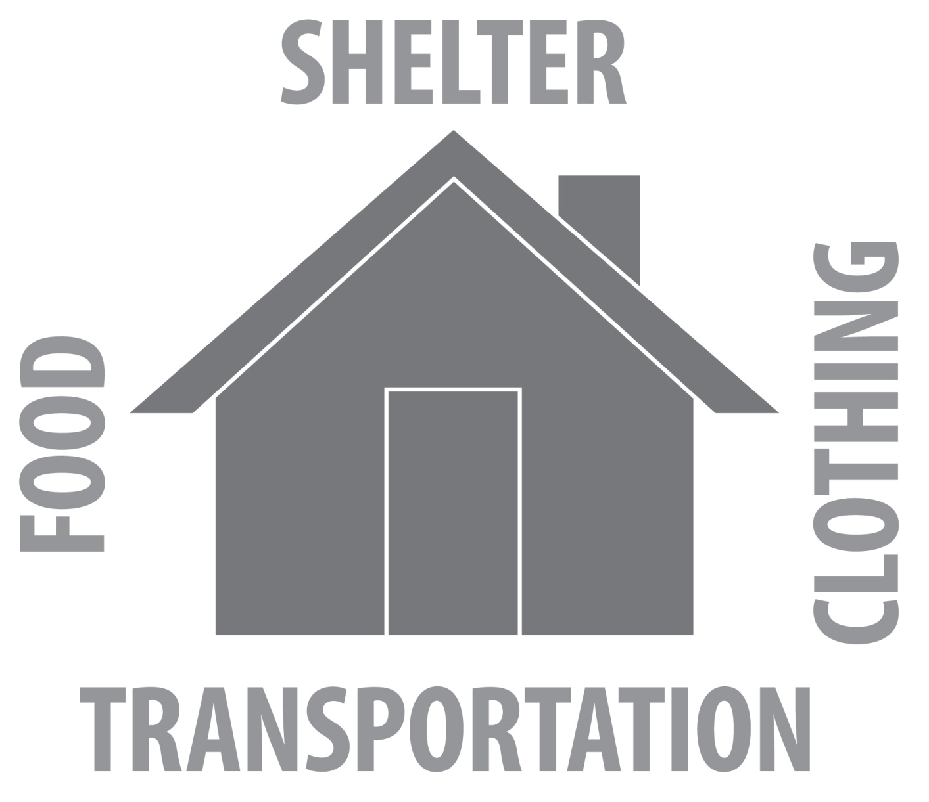
TRANSPORTATION
CLOTHING
FOOD

Pay necessities first.
1. Food
2. Shelter
3. Clothing
4. Transportation

