ElderCare
FINANCIAL AWARENESS

YOUR MONEY

TABLE OF CONTENTS

Introduction Page 3
Identity Theft Page 4
Types of Identity Theft
If You Think You Might Be a Victim
Lottery Scams Page 5
Signs of a Lottery Scam
Lottery Scams Discussion
Utility Scams Page 7
Types of Utility Scams
Home Improvement Scams Page 8
Signs of a Home Improvement Scam
Signs of an Untrustworthy Contractor
Recognizing a High Pressure Sales Tactic
Home Improvement Scams Discussion

FINANCIAL AWARENESS INTRODUCTION

The goal of the ElderCare program is to stop financial abuse of senior citizens and give you the tools to take control of your finances.

After going through this program, you will be able to:
- Recognize common financial scams.
- Understand the negative effects scams can have on your
financial resources.
- Identify trustworthy sources of financial advice and assistance.

Be S.M.A.A.R.T.
A recent study estimates that the elderly are swindled out of nearly $3 billion each year.

Another study found that 1 in 5 senior citizens had been the victim of a financial scam.

43% of Americans spend more money than they earn.
Stop! Take time to think through any financial decisions you make.
Make decisions on your own time, not because others pressure
you to decide quickly. Never fall for high-pressure sales tactics.
Avoid businesses that contact you directly. You know your
needs best and can contact services when you need them.
Ask questions about any financial deal you make. Know what
you are entering into and that it is exactly what you want.
Research your options before making decisions.
Talk to people you trust before making a financial decision.

YOUR MONEY | IDENTITY THEFT

There are many ways that scammers can run away with your money. One of the most common ways is by taking or manipulating your personal information.
Identity theft occurs when your personal information is stolen and used to commit fraud or other crimes. It can be financially devastating and ruin your credit. There are many different ways your identity and personal information can be compromised.
Types of Identity Theft
PROTECT YOURSELF
Be suspicious of any requests that ask you to wire money.
Make your passwords difficult to guess. Use a combination of numbers, letters and symbols.
Never provide personal information to anyone via email.
Never give out personal information on the phone unless you’ve confirmed the identity of the person or organization.
Shred all documents that contain your personal information before throwing them away.
Do not submit personal information online, including payment information, unless you are sure you are using a secure internet connection.
Dumpster Diving. Stealing documents containing personal
information from your trash.
Old Fashioned Stealing. Taking your purse, wallet, mail, etc.
to obtain your personal information.
Telephone Calling. Calling you and pretending to be a friend,
a government agency or a bank and asking for your personal
information.
Hacking. Hacking into your email or other online accounts to
obtain personal information.
Phishing. Pretending to be credit card companies or other
organizations and seeking personal information from you via
telephone calls, emails or online pop-up ads.
Medicare Identity Theft. Caller pretending to be a Medicare representative to obtain your personal information to steal from Medicare or from your personal accounts.
If You Think You Might Be a Victim
Contact your local law enforcement.
Contact a credit reporting agency to place a fraud alert on your
account and to determine if any accounts have been opened in
your name.
Contact your creditors to notify them of the theft. Close your
accounts if necessary.
File a complaint with the Federal Trade Commission.
Keep track of any documentation showing identity theft.
YOUR MONEY | LOTTERY SCAMS

What could be better than receiving a phone call, email or letter saying you’ve won money? Unfortunately, this could be another way for financial scammers to take advantage of you. It’s called a lottery scam.
Signs of a Lottery Scam
PROTECT YOURSELF
If it sounds too good to be true, it probably is. Unsolicited phone calls, emails and letters promising you’ve won lots of money should not be trusted.
If they call you, hang up.
If they write you, throw it away.
If they email you, mark it as spam and don’t answer it.
Remember, no real lottery will ever ask you for money to claim a prize.
Never give out personal information or credit card information over the phone.
You receive an unsolicited phone call, email or letter saying
you’ve won a lot of money.
You are told you must pay money or give out personal
information in order to claim a prize.

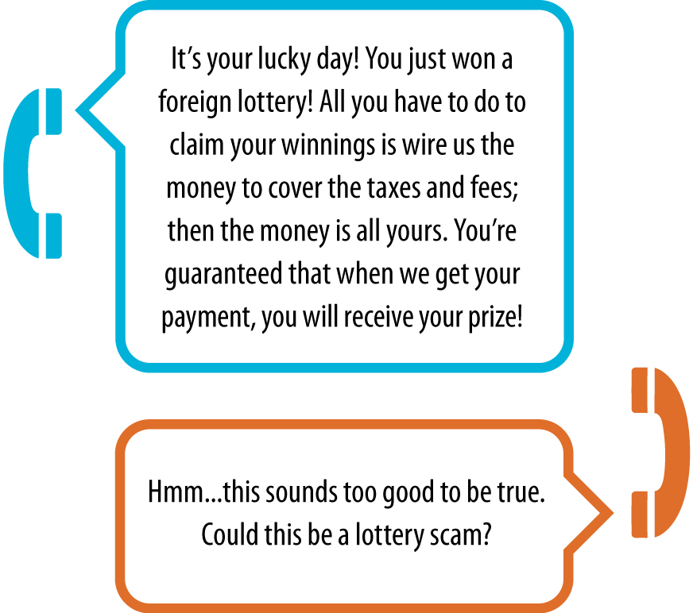

YOUR MONEY | LOTTERY SCAMS DISCUSSION

Tom in Trouble—What would you do?
Tom is a 72-year-old father of three children, and he has four grandchildren. He is a retired, well-educated professional. Because of the nation’s recent financial crisis, many of Tom’s investments have failed. He finds himself unable to afford the retirement he had hoped for and unable to help out his loved ones as much as he had planned.
Tom received a call from a man who told him that he won a million dollars in a Canadian lottery but before he could collect the money, he would have to pay taxes. Tom was very excited; he finally had a stroke of good luck! The man told him to send a cashier’s check for $750 to their representative in Jamaica. Over the next year, Tom sent money on 13 occasions, totaling almost $100,000. The last payment sent was for about $20,000. The bank put a stop on this transaction and informed Tom that he was probably the victim of a scam. Tom was now in a much worse financial situation than he was before. He had lost his retirement in hopes of eventually receiving lottery winnings. Since last month, the man has left over a dozen voicemail messages for Tom. Tom has stopped taking his calls.

1. Where did Tom go wrong?
2. What should Tom have done when the man first contacted him?
3. What should Tom do now?
4. What can people in Tom’s shoes do to protect themselves from these types of frauds?

YOUR MONEY | UTILITY SCAMS

Financial scammers often try to infiltrate the everyday transactions in our lives. A growing form of fraud involves one of the most common parts of our lives, and one we often don’t think about: utility scams for services like gas, water and electricity.

Types of Utility Scams
PROTECT YOURSELF
Utility insurance is never mandatory.
It can be tempting to purchase
utility insurance but you can
provide yourself the same coverage by saving a little each month to cover an unexpected repair expense.
Never show a door-to-door salesman your bill!
Never sign anything too quickly—take time to read it and get help from people you trust.
Never give out personal information or credit card information over the phone.
Shred your bill each month after you pay it so that your information doesn’t fall into the wrong hands.
1. Utility Insurance Scams
Utility insurance allows a homeowner to insure utility lines (like telephone and water lines) against costly damage. Utility insurance itself is legitimate, but often the solicitation by companies who are selling it is misleading. Letters urging you to buy insurance often appear to come from the utility company itself or tell you that insurance is mandatory.

2. Utility Provider Change Scams
Financial scammers from third party companies will try to trick you into switching to their service and then charge you hidden or increased fees.
They may come to your house claiming they can save you money and asking to see your personal account information.

3. Utility Identity Theft
Utility account information can make it easy for a financial scammer to steal your identity.
Scammers may call and claim your bill is overdue, asking you to give them your account information and credit card number so they can quickly pay the bill. After they get this personal information, they can use your cards to make purchases online or even to pay their own utility bills.

YOUR MONEY | HOME IMPROVEMENT SCAMS

Homes require a lot of care, and financial scammers know that people are willing to spend a lot of money to fix up their homes or restore them after a storm or disaster. Home improvement scams, usually carried out by contractors, take advantage of this vulnerability and can be extremely costly.
Signs of a Home Improvement Scam
PROTECT YOURSELF
Take time to think about a
contractor’s offer. Don’t sign
anything on the spot.
Don’t deal with door-to-door salespeople. Get recommendations from friends and family you trust.
Always get multiple estimates on home repair work.
Make sure a contractor provides you with a written contract agreeing to do the work you want done.
Don’t let a contractor start work on your home until all financial arrangements are final and you are comfortable with them.
- Unsolicited offers for home repairs.
- High pressure sales tactics.
Signs of an Untrustworthy Contractor
- He solicits door-to-door and doesn’t provide company
information or references.
- She pressures you to sign a contract immediately.
- He asks for cash payment or a check made payable to an
individual, not a company.
- She uses more than one contract for a single home repair
in order to confuse you and hide the cost of the work.
- He starts the work before you have a chance to see the
financing terms.
- She adds extra, hidden charges above the negotiated price.
- He claims there is a “cash” contract that doesn’t contain
financing terms, although the deal is intended to be financed.
Recognizing a High Pressure Sales Tactic
- A contractor uses a “bait and switch” tactic. He initially offers
a low price then later raises the price for a false reason.
- A contractor misrepresents the urgency of the repair or the
finance terms.
- A contractor claims that you are receiving a discount, but in
reality you are paying market price.

YOUR MONEY | HOME IMPROVEMENT
SCAMS DISCUSSION

How can I recognize a high pressure sales tactic?

1. What does a “bait and switch” sales tactic look like? Think of a scenario and explain how this could be used to scam you.
2. What are the consequences of committing to a contractor before you’ve signed a paper agreement that details the work he will do?
3. How could high pressure sales tactics be enticing to people who need home improvement work done? How can you avoid giving in to people who try to pressure you into something?

